Bandwidth Requirements for Salt.

Assumptions

- These results are assuming InfoPath content is supplied. The figures will be different for Toolbook content.
- Use has a fairly clear cache.
i.e. The user has not attempted these lessons and quizzes before and therefore has not cached the images etc on their machine. If this was the case then the figures below would be significantly lower.
- That the Contract fundamentals course is roughly indicative of an average piece of content.

Results

- One lesson session is approximately 600 – 700K.
The exact value depends on two factors:
    - The number of images in the lesson.
    - The number of pages in the lesson.

- One Quiz session is approximately 500K
The exact value depends on two factors:
    - The number of images in the Quiz.
    - The number of questions that a user is attempting according to their organization’s configurations

Actions performed by the user:
Visit Salt home page.
Login
Sit one Lesson (14 Pages long)
View results
Back to home page

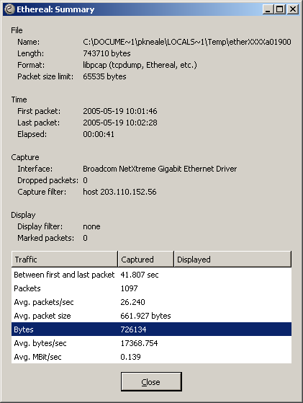 | 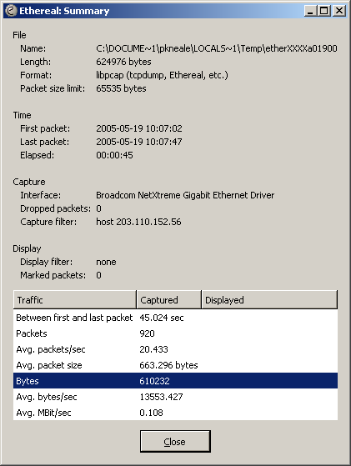

Actions:
Visit Salt home page.
Login
Sit one Quiz (10 questions long)
View results
Return to home page

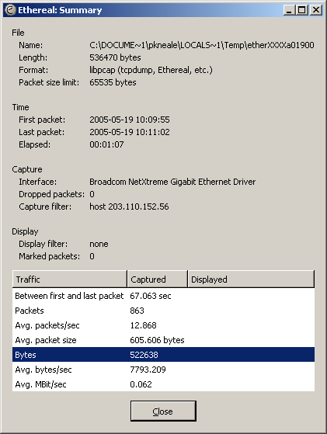 | 